This report covers both positions as both people work together on the majority of the items reported below.
Action Item From Previous Meeting - #1. Initiate paperless bank statements.
I have chosen not to go paperless as we lose the ability to see an image of the cheque written. We will continue to receive paper statements, which includes cheque images, although the online information will give us “up to the minute” information. Closed.
School District 72 parking lot “the use of”
Reminder that this parking lot is off limits 24/7 to anyone other than School District 72 employees and visitors. A copy of the letter has been taped to our Skating Club office door for reference.
Web Site
The web site has been updated to reflect the use of online registration and the change in the Coaches’ team. If anyone sees anything further that needs updating contact Lynda.
CRSC Facebook Page
Gill has given me Admin access so I can now manage requests from those wanting to join our FB page. It is important to note that careful consideration is to be given before approving a request to join.
Coach Contracts
Coach contracts for Rae Anne, Keri and Julia have been signed and are on their personnel files. Rae Anne and Keri have a contract specific to club-run programs and a memorandum of understanding to cover their ‘private’ lesson time on club ice. Julia has a contract specific to her role as CanSkate Coach.
Strategic Planning Session
Facilitated by Ron Bowles on August 21st. Attending were Diane, Marie, Shannon M., Lynda, Rae Anne, Keri and Julia. The Priorities for the 2016/2017 season are listed below. If the top 4 get done, then the next two can be completed. Master ‘comprehensive’ list is currently on Lynda’s wall in her office. Recommend small groups tackle each item and bring back the draft to the Board for approval/implementation.
- Internal Communication Policy
- Mission, Vision, Values
Visionary (community)
Missionary
Values (how)
- Conflict Resolution Policy and Procedures
- Coach Management System

- On Ice Environment and Skater Code of Conduct
- Marketing, Visibility and Memberships
Parking List
- Roles of Directors; Roles of Coaches
- Policies
- Coaches on Board
- Conflict Resolution and Skate Discipline Process
- Review Priority Policies
- Share Strategic Planning Information?
- Parent communication and education – problems on the ice.
- Role clarity re. Coaches
Safety
A skater was injured on the ice and through that incident it has become apparent that a local policy/process is needed. The ‘steps’ would need to start from the accident, to the call to transportation, to follow up and to reporting. It was discussed that Skate Canada has an Online Reporting tool that is available. It is also highly recommended that a doctor’s note be provided by the family to identify the skater as being cleared to return to the ice. The parent is interested in reviewing the draft and being given the opportunity to provide feedback.
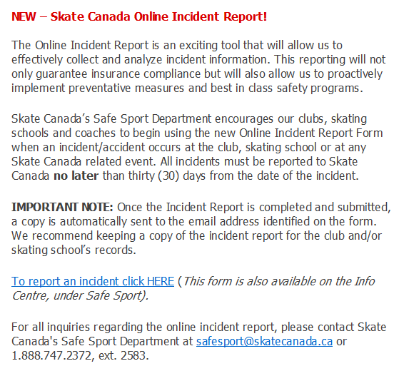
One discussion item at the Ice Summit back east was, “The new insurance is being implemented because of head injuries basically—which is the biggest percentage of insurance claims. Safe Sport is looking at coach’s loss of income due to injuries plus making sure no minor is abused by a coach.”
Action: Lynda will draft a Club policy with input from Coaches, etc. and present at October meeting for approval. Due Date: October 25
Marie is maintaining the Emergency contact list in the Skating Club office as well as uploading registrations to the Skate Canada database. Further discussion around the Emergency contact/health record information will be taken ‘offline’ as there are other methods for maintaining this information for each CRSC member.
Ice Show
March 11/17 (Saturday) / 2 shows. Action: Lynda will review volunteer positions in Uplifter to come up with the start of this Committee. Title of Ice Show: _____________. Initial meeting will provide the direction to the Committee and determine the Chair or Chairs.
Vancouver Island Region Meeting (Sept. 25) Highlights
President’s Meeting:
- Skate sharpening options. Greg (Comox $13), Jan (N. Cowichan $22), April Robson (250-701-3119 $12/figure skates; $6/hockey), Rushtons in Victoria $25, Tyler (Sandy Shores $15).
- Safety and security. Some Clubs were familiar with the Skate Canada Online Reporting form and some were not. Good discussion but no one actually had a process in place. One Club ‘bands’ a parent at ice show when the skater is signed in so that parent is the only one that can pick up that child.
- Policy that Coaches shouldn’t be picking up registrations as this is a Board/Executive responsibility.
- Meetings should not be held in a bar and even a home, but if at a home should be the President’s and no other people should be around. This is a business and should be treated that way in a professional manner.
- VISI, $25/club for food (cheque payable to Vancouver Island Region) and decide on theme raffle basket per club. Both to be forwarded to Betsy in January.
General Meeting:
- Reminder to Clubs to submit sanctions. Probably a good idea to use this form for fundraisers as well. When in doubt, submit a sanction.
- Kurt Browning seminar. Coaches were at the seminar to take notes and observe; under strict instruction to NOT take video or pictures; safety issue. If your Coach goes to show you anything on their phone you are to ask them to delete them immediately. Pics should be taken off the ice. Need to tighten up and be more professional. Overall the issue was around Coach professionalism. Due to the behaviour of some parents and some Coaches, future seminars may see these groups barred from attending. There were 102 skaters and there was lots and months of preparation that went into the organization of this event.
  - Clubs should talk with newer parents of skaters from the lower levels to discuss their conduct when attending seminars. Again, future seminars may have parents blocked. The focus is on skater development, to grow their love of skating and to grow skating on the island.
- Testing. When Coaches are conducting their assessments they can only assess their own skaters. In order for Coaches to assess they would have had to successfully complete the online course. Confirmation to be forwarded to the President. Due Date: October 15/16. Effective September 2017 it will be mandatory for STAR 1-5 to be assessed/tested by their respective Coaches.
- When completing the planned program sheets and submitting to the Data Specialist, it is important to remember to save each sheet as an individual document/file and saved as the skater’s name and event.
- Our region is hoping to get synchro going and possibly offering a clinic depending on interest. Could be taken from an ice show number; only need 8-9 skaters.
- Competition Manual is being revamped.
- Need runners and timers at VISI so if you can help that would be great.
- The changes with the STAR program are primarily being done by Ontario and BC.
- Next Vancouver Island Region meetings are January 29 and April 1st. If anyone is interested in coming you are welcome, just let Lynda know.
- More information coming out about the changes in the Societies Act. If our club is considered ‘member funded’ then we wouldn’t be eligible to get Gaming so it will be important to be recognized as ‘public funded’. Also, the definition of ‘conflict of interest’ would be any Board member who has a skater, grandchild skating. More information coming. Do not change your Bylaws.
- STAR package and ribbons are going up October 1st.
- Seminar for STAR 1 and 2 will be held Sunday, November 20th. More information to come. A parent information session will also be held. Don’t have to be attending competition to attend seminar.
- It will be important for each club to send a representation to the BC/YK AGM in 2017, May 5-7 on the Mainland. Topics will include the new Society Act and a Gaming workshop.
- Club Ranking is specific to BC only and may become ‘mandatory’ for the next season. This process is twofold; 1. Justifies numbers etc. to Gaming and supports Clubs in becoming more active.
- Officials Update Clinic is October 30th.

